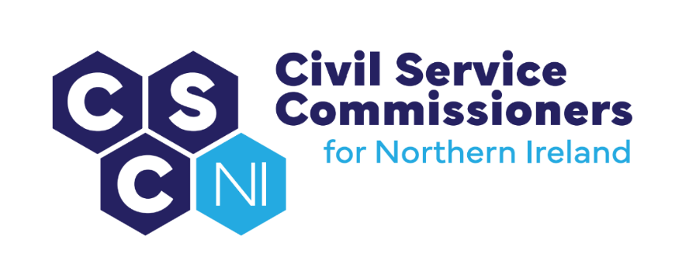

**civil Service Commissioners for Northern Ireland**

**Summary Record of Business Meeting**

**10am, Tuesday 18 June 2024**

**Erskine House, Belfast**

Attendees:

Commissioners - Deirdre Toner, Chairperson, Sinead Burns, Dr Lesley Carroll Secretariat - Amanda Martin, Heather Caulfield, Paula Kerr, Dawn Molloy

Apologies: None

# Introduction and Pre-Meeting Business

The Chairperson welcomed everyone to the meeting, including the new Staff Officer, Dawn Molloy.

## Any other business

* There were no items of additional business.

## Action Matrix from Business Meeting of 30 April 2024 (Paper 11/24)

* Commissioners noted the update on the action points from the 30 April 2024 Business Meeting.

## Matters arising and Conflicts of Interest

* No conflicts of interest were declared in relation to the business meeting agenda and papers and there were no matters arising.

# Secretary’s Report (Paper 12/24)

* In respect of the legal advice sought on potential amendments to the Recruitment Code, the Secretary advised that nothing has been received yet. The Secretary will send a reminder within the next two weeks.
* Arrangements for the visit by Baroness Gisela Stuart have changed slightly. The Secretary went through the updated schedule which was agreed upon by all. Confirmation that the changes also suit People & OD and NICS HR will also be sought. The location was confirmed as Erskine House.
* A governance review of sponsored bodies is being carried out by NIO and as a result, the Secretary informed that she will be meeting with an NIO representative to discuss current Sponsorship and support arrangements and identify if any changes are required. All confirmed that they are content with the current relationship.

## Equality and Diversity

* The Secretary advised that the application to Diversity Mark had been submitted and outlined the next steps involved. An outcome is expected by August on whether the application has been approved by an Independent Assessment Panel. Once approval is received, the Secretariat will take forward actions towards seeking bronze accreditation.
* Commissioners confirmed that they were content for the Annual Progress Report on their Public Authority Statutory Equality and Good Relations to the Equality Commission to be submitted also.

# Corporate Management and Governance

## Finance

* The Secretary presented an overview of Q1 financial position.
* It was noted that the number of SCS competitions that Commissioners have been asked to Chair has started to increase and that this trend is expected to continue.

# Business Planning Documents

## Business Plans

* Commissioners noted the update on Q1 targets and objectives in the 2024/25 Business Plan.

## Corporate Risk Register

* Some recent changes have been made to the Corporate Risk Register to reflect recent developments and mitigation measures. All draft changes were accepted.

## Learning and Development Plan

* An update on Q1 targets and objectives on the Learning and Development Plan was provided and Commissioners were reminded that the next workshop would feature the NICS Women’s Champion and consider barriers to recruitment and selection for women.

## Business Continuity Plan

* An up to date paper copy of the Business Continuity plan was disseminated to all, to be retained in a secure location.

## Register of Recommendations from Reports including NIAO Report on Capacity and Capability in the NICS and PAC Report

* There have been no changes to the Register since the Business Meeting on 30 April 2024.

# Staffing

* It was noted that the Secretariat now has a full complement of staff (3.2FTE) as of 1 June 2024.

# Communications

* An update was provided on the progress of the training video outlining what Commissioners do. Design options are currently being explored and Commissioners will be kept updated on progress.
* The Commissioners social media platform, X, is continuing to be updated when possible.

# Housekeeping

* Following the completion of security clearance, Commissioners are now able to access facilities at Erskine House.
* The Secretariat reminded Commissioners that the move from NICS Payroll to Liberata would be complete by the end of June.

# Annual Report

* Further to a letter received from the DoF Permanent Secretary, the Recruitment to the NICS Annual Report will now be submitted by 28 June 2024. This will still leave time for a draft of Commissioners’ Annual Report to be circulated, and comments made by 31 July 2024, with the aim of the final report being published by the end of August 2024.

# Recruitment Code

* A short discussion ensued in respect of the JobStart scheme and the issue which had been raised by the NICS regarding the three months’ notice required by the Recruitment Code for requests to make appointments permanent upon successful completion of the relevant scheme under Regulation 3(e). Given that JobStart temporary appointments are for nine months, the NICS would welcome more time to determine whether permanency is appropriate.
* It was suggested that additional wording could be included in the Recruitment Code to deal with this issue, but this will be addressed when other planned changes to the Code are being made. The Secretary will respond to the NICS on this matter.

# Competitions Update

* An update on live SCS competitions being chaired by Commissioners was noted by all.

# Casework Update

## Appointments Approved by Way of Exception

* A report accompanied by narrative and analysis on applications made by NICS’ Departments to Commissioners to approve Exception to Merit over the past 5 years was presented and discussed. It was agreed that this will be presented to Commissioners on an annual basis.

## Code of Ethics

* No Code of Ethics casework was undertaken in Q1 reporting period.

# Complaints and Queries

* Commissioners noted that one recruitment related query was received which was referred to the NICS.

# Requests for Information

* Commissioners noted that there were no requests for information during the reporting period.

# Future Meetings

* Commissioners noted all future meetings which have been scheduled for 2024/2025. They further noted that the annual meeting with the HOCS and NICS Board had yet to be arranged.

# Audit Report (Paper 13/24)

## Progress against Audit and Review Plan 2023/24

### Audit of competitions below SCS

* Commissioners discussed the NICS management response, received on 4 June 2024, regarding the recommendations stemming from the audit of competitions below SCS. Following discussion, a letter of response to the NICS was agreed.

## Progress against Audit and Review Plan 2024/25

### Review of Key Stages of Competitions below SCS

* Commissioners noted the arrangements Secretariat has agreed with the NICS for Commissioners’ observation of key stages of competitions below SCS.

### Review of Secondments below SCS

* A table of the number of secondments to be audited by the Department was presented to Commissioners and Commissioners noted that the audit has commenced.

### Article 6 Approval Process Audits

* Commissioners were reminded of the competitions which have been selected for Article 6 Approval Process audit and were advised that the Secretariat has requested the paperwork from HR Connect for the audit.

# Matters arising from the Audit and Engagement Meeting 14March 2024

## Initial Sift and Read Across

* Following discussion at the Recruitment and Selection Development Group, the Secretariat is currently waiting on NICS to come back with the background to the introduction of ‘read across’ and the expectation on how this is applied. Once received, Commissioners will consider the outstanding action point from the Audit and Engagement meeting.

## NICS Recruitment and Selection Training

* Commissioners were reminded that there is an outstanding action for the NICS to involve Commissioners in the review of recruitment and selection training, including reviewing the training provided on the role of Commissioners. They were further reminded about the current development of an explanatory video on what Commissioners do, and it was suggested that the Secretariat will discuss with the NICS a proposal that this video could form part of the training package.

## Agency Workers in the NICS

* A summary of agency worker information was provided to Commissioners who noted that the number of agency staff is continuing to increase. However, the hope is that these numbers will start to reduce when placements are made from the recent competition for administrative officers in DFC.

# Response to People & OD on Review of HR Policies (Paper 14/24)

* Following the policies that had been sent through from People & OD, and after consideration by Commissioners, a draft response was updated that all agreed would be forwarded on.

# Review of Article 6 Procedures Paper (15/24)

* It was agreed that the Secretariat would review the Article 6 process to see if it remained fit for purpose or if any changes should be made.

# Housekeeping issues

* Commissioners were reminded to update their register of interests or provide a nil return and to submit their travel receipts and fees in a timely manner.

**Office of the Civil Service Commissioners   
for Northern Ireland**