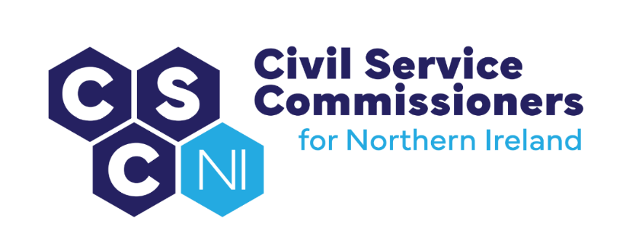

civil Service Commissioners for Northern Ireland
Summary Record of Business Meeting
9.30am, Tuesday 16 January 2024
Erskine House, Belfast

Attendees:
Commissioners: Deirdre Toner, Chairperson, Sinéad Burns, Dr Lesley Carroll Secretariat: Amanda Martin, Heather Caulfield, Jayne Logan

Apologies: None

Introduction and pre-meeting business
The Chairperson welcomed everyone to the meeting.

Any other business

No items were raised as additional business.

Action matrix of April business meeting (paper 01/24)
Commissioners agreed the Summary Record and action points from the 21 September 2023 Business Meeting.

Matters arising and conflicts of interest

No conflicts of interest were declared in relation to January’s business meeting agenda and papers.

Secretary’s report (paper 02/24 annex a, b, c & d)
The Secretary presented the Secretary’s Report and outlined the key outputs and activities in addition to routine and ongoing activities (key management information presented in Annexes A, B, C & D) since the last business meeting on 21 September 2023 that included:

- Consultation on Statistics Reporting on Equality, Sickness and Recruitment
(Action: Commissioners agreed to seek a further meeting with NISRA to discuss comparator figures between recruitment and the economically active population);

- Consultation and Engagement with the NICS on a range of policy proposals;

- Recruitment and Selection Development Group meeting held on 4 December 2023;

- Ministerial Involvement (Recruitment Code);

- Proposed meeting with Baroness Gisela Stuart, UK Civil Service Commission;
(Action: Agree date and programme for visit from First UK Commissioner)

- Engagement with DoF Permanent Secretary;

- Policy Review (Internal/Partnership) – Complaints Procedure and Data Sharing;

- Governance and Planning (including submission of Mid Year Stewardship Statement and Review of Risk Register)

- Equality, Diversity and Inclusion (including Racial Equality Workshop held on 4 October 2023, Diversity Mark Charter signed on 14 December 2023 and meeting with Equality Commission to be held later in the day);

- Development of New CSC NI Website; and

- Housekeeping.

Corporate Management and Governance

2023/24 Budget Report
The Secretary referred Commissioners to the table detailed within the report that provided an overview on the current financial position.

2023/24 Business Planning Documents
The Secretary updated the Commissioners on the quarterly progress of the Business Planning documents.

Commissioners noted the following:

- Business Plan: on track to achieve all Q3 targets and objectives in the 2023/24 Business Plan.

- Commissioners were asked to ensure they completed the mandatory training on Civil Service Learning Platform and to complete the Information Assurance Statement forms which would be emailed following the meeting.

Action: Commissioners to competed Information Assurance Statements

- Risk Register: Commissioners discussed the Corporate Risk Register and approved the revisions resulting in CR3 being split into Risks 3a and 3b.

Actions: Accept the revisions to the Risk Register.

- Learning and Development Plan: All Q3 targets and objectives were on track to be achieved with the majority of training sessions being delivered online.

Staffing – Update
The Secretary advised that the existing staff complement sat at 2.4 FTE following the Deputy Principal leaving on 5 January to take a post elsewhere within the NICS.
Commissioners were advised that the secondment of the current Secretary was due to end on 31 March 2024 and that both the Deputy Principal and Secretary posts had been advertised.

Commissioners were also provided with an update on the secondment terms for the remaining staff members.

Conflict of Interest
Commissioners considered the Conflict of Interest research paper and discussed the definition of a ‘Conflict of Interest’.
Action: Write to the NICS to ask if the NICS has considered the NAO (National Audit Office) definition and where the definition currently being used in the NICS Recruitment Policy and Procedures Manual comes from.

2023/24 Annual Report
The Secretary outlined the timetable for preparing and printing of the Annual Report and Commissioners were content with the proposals.

Complaints and Queries
Commissioners noted the update on complaints/queries.

Requests for Information
Commissioners noted that no Freedom of Information requests had been received during this quarter.

Recent and Future Meetings

Commissioners noted the table of recent and future meetings and agreed to provide details of their availability in the coming weeks to facilitate additional meetings to include:

- A meeting with Baroness Gisela Stuart, UK Civil Service Commission;
- A Meeting with NISRA re recruitment reporting statistics;
- A gender related language and gender identity workshop; and
- An Audit and Engagement meeting.

Action: A meeting poll would be sent to Commissioners to gauge their availability for future meetings.

Audit Report (Paper 03/24 and Annex A)
The Chairperson invited the DP Audit to present the Audit Report.

The DP advised the draft findings from the Audit of Competitions below SCS had been forwarded to NICS for a factual accuracy check in November 2023 and a response was expected shortly.

Agency Workers in the NICS
Commissioners noted that the number of Agency workers in the NICS was at 13.3% of the total workforce and had increased over the last few years (from 9.8% in March 2021). Commissioners were aware that the NICS were recruiting for permanent administrative officers to fill a large number of vacancies. It is anticipated that the number of agency workers would decrease as permanent positions were filled.

Outstanding Issues
An update on outstanding actions was provided to Commissioners in relation to the following:

- SIB Review;
- minutes of the previous Audit & Engagement meeting (26 October);
- Commissioners’ letter to NICSHR of 22 November 2023 regarding sifting issues; and
- Commissioners’ draft Audit plan 2024/25.

The DP detailed items for discussion at the next Audit and Engagement meeting (which would be organised from the dates provided from the meeting poll).

Diversity Mark
Commissioners discussed the Diversity Mark Bronze Accreditation Application and talked through how best to achieve the identified targets.

The Secretary advised that the Secretariat would be meeting with Diversity Mark colleagues on 18 January to discuss the strategy and targets. Commissioners’ comments would be sought before submission of the final Diversity Mark application.

The Commissioners continued that guidance would be useful on suitable language that was free from any words or phrases that could be offensive, discriminatory, show bias or promote stereotypes or assumptions.

Action: (i) Agree a date for Gender Related Language (Recruitment) and Gender Identity workshop; and (ii) Share links with Commissioners on language good practices.

Website Design (Paper 04/24 Annex A, B & C)
Commissioners reviewed and agreed to sign off the Home Page visuals and text. They continued discussions on the draft ‘What We Do’ and ‘About Us’ pages and asked for several changes to be made.

In addition to the changes, Commissioners suggested that Easy-read versions of the ‘Recruitment Code’ and the ‘Guidance on Raising a Concern under the NICS Code of Ethics’ would ensure they were more readily understood by a wider audience and agreed that quotations be sought for their translation.

Action: (i) Forward Home Page to web developer; (ii) Update the ‘What We Do’ and ‘About Us’ page and forward to Commissioners for further comment; and (iii) Make enquiries about having existing material edited/translated into plain English/easy-read English.

Housekeeping Issues
Commissioners are to be issued with security passes for Erskine House and will be forwarded the relevant paperwork for completing.

Action: Commissioners to complete security clearance paperwork.

Commissioners were reminded of the policies and procedures for claiming mileage and fees.

A.O.B.

Background for Virtual Meetings

As more and more meetings are virtual or hybrid the Commissioners asked the Secretariat to look into options for creating a virtual background for meetings.

Action: The Secretariat to source a corporate backdrop for virtual meetings.

Register of Interests (Paper 05/24)

Commissioners were reminded to provide any updates to the Register of Interests in writing/by email to the Secretariat.
Office of the Civil Service Commissioners
for Northern Ireland

